**A PROJECT REPORT**

### ON

**E-Commerce Website**

**For the partial fulfillment for the award of the degree of**

**BACHELOR OF TECHNOLOGY**

#### In

**COMPUTER SCIENCE AND ENGINEERING**

**Submitted By**

**Mudassir Hussain (1901920100172)**

**Mohit (1901920100168)**

**Under the Supervision of**

**Dr. Deepti Mishra**



**G.L. BAJAJ INSTITUTE OF TECHNOLOGY &**

**MANAGEMENT, GREATER NOIDA**



**Affiliated to**

**DR. APJ ABDUL KALAM TECHNICAL UNIVERSITY,**

**LUCKNOW**

**2021-22**

**Declaration**

We hereby declare that the project work presented in this report entitled **“E-Commerce Website”*,*** in partial fulfillment of the requirement for the award of the degree of Bachelor of Technology in Computer Science & Engineering, submitted to A.P.J. Abdul Kalam Technical University, Lucknow, is based on my own work carried out at Department of Computer Science & Engineering, G.L. Bajaj Institute of Technology & Management, Greater Noida. The work contained in the report is original and project work reported in this report has not been submitted by me/us for award of any other degree or diploma.

|  |  |  |  |  |  |
| --- | --- | --- | --- | --- | --- |
| Signature: |  |  | Signature: |  |  |
| Name: Mudassir Hussain |  |  | Name:  Mohit |  |  |
| Roll No: 1901920100172 |  |  | Roll No: 1901920100168 |  |  |
|  |  |  |  |  |  |
|  |  |  |  |  |  |
|  |  |  |  |  |  |
|  |  |  |  |  |  |
|  |  |  |  |  |  |

Date:

Place: Greater Noida

## Certificate

This is to certify that the Project report entitled **“ E-Commerce Website ” done by Mudassir Hussain (1901920100172), Mohit(1901920100168)** is an original work carried out by them in Department of Computer Science & Engineering, G.L Bajaj Institute of Technology & Management, Greater Noida under my guidance. The matter embodied in this project work has not been submitted earlier for the award of any degree or diploma to the best of my knowledge and belief.

Date:

##### Dr. Deepti Mishra Dr. Sanjeev Kumar Pippal

**Signature of the Supervisor Head of the Departmen**

**Acknowledgement**

The merciful guidance bestowed to us by the almighty made us stick out this project to a successful end. We humbly pray with sincere heart for his guidance to continue forever.

We pay thanks to our project guide **Dr. Deepti Mishra** who has given guidance and light to us during this project. Her versatile knowledge has cased us in the critical times during the span of this project.

We pay special thanks to our Head of Department Dr. Sanjeev Kumar Pippal who has been always present as a support and help us in all possible way during this project.

We also take this opportunity to express our gratitude to all those people who have been directly and indirectly with us during the completion of the project.

We want to thanks our friends who have always encouraged us during this project.

At the last but not least thanks to all the faculty of CSE department who provided valuable suggestions during the period of project.

## Abstract

In today’s fast-changing business environment, it’s extremely important to be able to respond

to client needs in the most effective and timely manner. If your customers wish to see your

business online and have instant access to your products or services.

Online Shopping is a lifestyle e-commerce web application, which retails various fashion and

lifestyle products. This project allows viewing various products available enables registered users

to purchase desired products instantly using Instamojo payment processor (Instant Pay).

This project provides an easy access to Administrators and Managers to view orders placed.

In order to develop an e-commerce website, a number of Technologies must be studied and

understood. These include multi-tiered architecture, server and client side scripting techniques, implementation technologies, programming language (such as PHP) and relational databases.

This is a project with the objective to develop a basic website where a consumer is provided

with a shopping cart application and also to know about the technologies used to develop such

an application.

This document will discuss each of the underlying technologies to create and implement an

ecommerce website.

#### TABLE OF CONTENT

Declaration.................................................................................................. (ii)

Certificate ................................................................................................................. (iii)

Acknowledgement .......................................................................................................... (iv)

Abstract ................................................................................................................. (v)

Table of Content................................................................................................................. (vi)

List of Figures ………………………………………………………………………… (vii)

|  |  |  |
| --- | --- | --- |
| **Chapter 1.** | **Introduction ..........................................................................................** | Pg.No.: 8-12 |
| 1.1 | Problem Definition….............................................................................. |  |
| 1.2 | Project Overview..................................................................................... |  |
| 1.3 | Project Specifications………………………………………………….. |  |
| **Chapter 2.** | **Methodology Development Model........................................................** | Pg.No.:13-16 |
| 2.1 | Development Model…………………………………………………... |  |
| 2.2 | Tools and Technique…………………………………………………. |  |
|  |  |  |
| **Chapter 3.** | **Problem Formulation ……………………………………………….** | Pg.No.: 17 |
| 3.1 | Profile of Problems…………………………………………………... |  |
| 3.2 | Problem Analysis…………………………………………………….. |  |
| **Chapter 4.** | **System Analysis & Design …............................................................** | Pg.No.: 18 |
| 4.1 | System Analysis…………………………………………………….. |  |
| 4.2 | System Design………………………………………………………. |  |
| **Chapter 5.** | **Implementation………….…............................................................** | Pg.No.:19-22 |
| 5.1  5.2 | Description…………………………………………………………………  Functions Implementation ……………………………………………….. |  |
| **Chapter 6.** | **Result………………………..............................................................** | Pg.No.:23-26 |
| 6.1. | Structure of the project…………………………………………………... |  |
| 6.2. | Screenshots………………………………………………………………………... |  |
| **Chapter 7.**  7.1  7.2  7.3 | **Conclusion, Limitation & Future Scope.……………………….....**  Conclusion………………………………………………………………..  Limitation………………………………………………………………  Future Scope……………………………………………………………… | Pg.No.: 27 |
| **Chapter 8.** | **Bibliography and References………………………………………………………………..** | Pg No.: 28 |
|  | |  |
|  | |  |

**LIST OF FIGURES**

|  |  |  |
| --- | --- | --- |
|  |  |  |
| **Figure 1:** | E-Commerce System | Pg. No.: 10 |
| **Figure 2:** | Sequence Diagram | Pg. No.: 11 |
| **Figure 3:** | Flowchart of E-Commerce | Pg. No.: 12 |
| **Figure 4:** | Waterfall Model | Pg. No.: 14 |
| **Figure 5:** | Basic PHP of the Project | Pg. No.: 20 |
| **Figure 6:**  **Figure 7:**  **Figure 8:**  **Figure 9:**  **Figure 10:**  **Figure 11:**  **Figure 12:**  **Figure 13:**  **Figure 14:** | Basic CSS of the Project  Available products on the website  User Registration  Home Page  Admin Page  All Products  Registration Page  Login Page  Payment Page | Pg. No.: 20  Pg. No.: 21  Pg. No.: 22  Pg. No.: 24  Pg. No.: 24  Pg. No.: 25  Pg. No.: 25  Pg. No.: 26  Pg. No.: 26 |
|  |  |  |
|  |  |  |
|  |  |  |

# Chapter 1

## Introduction

**1.1 Problem Definition**

One must know what the problem is before it can be solved. The basis for ecommerce is to buy

products online and save the timing.

An E-commerce, who want to buy any product of their need, has to contact different Shoppers,

before deciding upon a particular Product that best suit his needs, requirements and satisfaction.

Moreover, most of the work involved in this development process has to be done manually which

is very time consuming and cumbersome and also, it reduces the efficiency, accuracy.

To know the facts and understanding of the problem in detail, System Analysis is carried out.

It is the process of studying the business processes and procedures, generally referred to as

business systems, to see how they can operate and whether improvement is needed.

**1.2 Project Overview**

Computer plays an important role in our daily life. Anything we want we can get only in one

mouse click. Speed, reliability and accuracy of the computer make it a powerful tool for different purposes. A very important and basic need of today’s modern business world is the quick

availability and processing of information using computer. One can easily get the type of required information within a fraction of a second. The project that we have taken is also in this category

which is used in our daily life whenever we want to purchase some items we can easily get them

at our home.

E-commerce (electronic commerce) is the buying and selling of goods and services, or the

transmitting of funds or data, over an electronic network, primarily the internet. These business transactions occur either as business-to-business (B2B), business-to-consumer (B2C), consumer-

to-consumer or consumer-to-business. The terms e-commerce and e-business are often used interchangeably. The term e-tail is also sometimes used in reference to the transactional processes

for online shopping.

**1.3 Project Specifications**

**External Interfaces**

- This interface will be actual interface through which the user will communication with the

application and perform the desired tasks.

I.D: Admin login

Role: Admin wishes to login to the system

Precondition: Username and Password

Success end Condition: Main option of screen display

Failed end Condition: User has entered incorrect Username and Password or both.

ID: Edit

Precondition: User has successfully navigated to the search result.

Success end Condition: User has successfully made the changes.

**Software Product Features**

Ecommerce system

Login Information System

* Description

-The system will maintain the login information of its user to enter in to the software

* Validating Checks

-Administrator need to login the unique id and password.

-Contact number should have maximum 10 digits.

-All the details must be fill up.

-Email address should be in the proper format.

* Sequencing information

-Login information should be filled before the user allowed.

* Error Handling

-If user doesn’t filled up validate information then the system display error message for

user and request to enter the validate information.

Performance required

* Security

-System should be Protected from unauthorized access Where the validate Username

and Password are required so no other can access.

* Maintainability

-System should be design in a maintain order. So it can be easily modified.

Data Design

* Data Model:

-A database model is a type of data model that determines the logical structure of

a database and fundamentally determines in which manner data can be stored, organized and

manipulated.

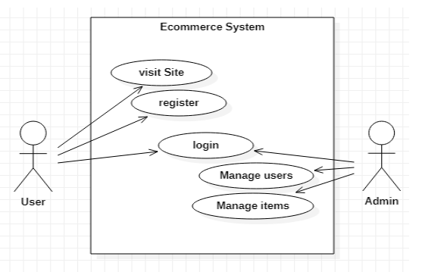

Figure 1: E-Commerce System

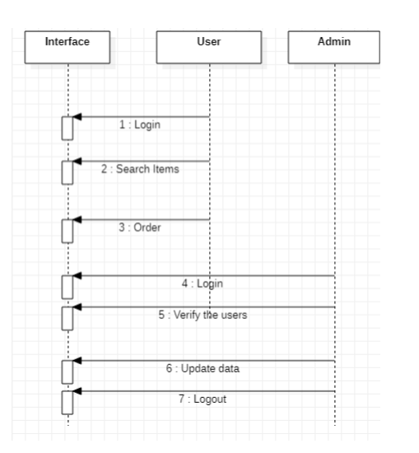

Figure 2: Sequence Diagram

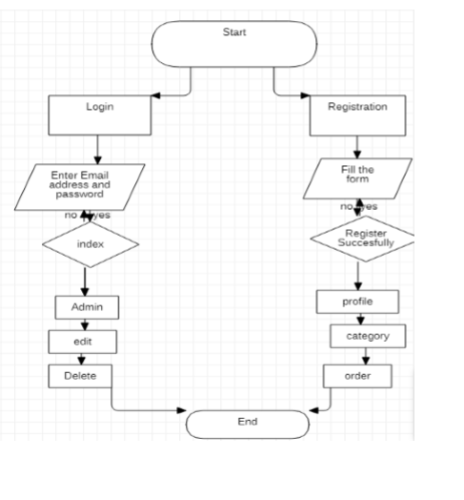

Figure 3: Flowchart of Ecommerce

# Chapter 2

## Methodology Development

**2.1 Development Model**

The sequential phases in Waterfall model are −

* **Requirement Gathering and analysis** − All possible requirements of the system to be

developed are captured in this phase and documented in a requirement specification document.

* **System Design** − The requirement specifications from first phase are studied in this phase

and the system design is prepared. This system design helps in specifying hardware and system requirements and helps in defining the overall system architecture.

* **Implementation** − With inputs from the system design, the system is first developed in

small programs called units, which are integrated in the next phase. Each unit is developed and

tested for its functionality, which is referred to as Unit Testing.

* **Integration and Testing** − All the units developed in the implementation phase are

integrated into a system after testing of each unit. Post integration the entire system is tested

for any faults and failures.

* **Deployment of system** − Once the functional and non-functional testing is done; the

Product is deployed in the customer environment or released into the market.

* **Maintenance** − There are some issues which come up in the client environment.

To fix those issues, patches are released. Also to enhance the product some better versions

are released. Maintenance is done to deliver these changes in the customer environment.

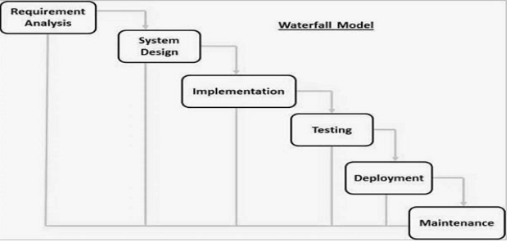

Figure 4: Waterfall Model

**2.2 Tools and Technique**

1. Php
2. Xampp
3. Mysql
4. HTML
5. Sublime text
6. Java Script
7. Css

* **Php**

Hypertext Preprocessor (or simply PHP) is a server-side scripting language designed for

Web development, but also used as a general-purpose programming language.

It was originally created by Rasmus Lerdorf in 1994,] the PHP reference implementation

is now produced by The PHP Group. PHP originally stood for Personal Home Page,] but

it now stands for the recursive acronym PHP: Hypertext Preprocessor.

PHP code may be embedded into HTML code, or it can be used in combination with

various web template systems, web content management systems, and web frameworks.

PHP code is usually processed by a PHP interpreter implemented as a module in the web

server or as a Common Gateway Interface (CGI) executable. The web server combines the

results of the interpreted and executed PHP code, which may be any type of data, including images, with the generated web page. PHP code may also be executed with a command-line interface (CLI) and can be used to implement standalone graphical applications.

* **Xampp**

XAMPP is a free and open source cross-platform web server solution stack package

developed by Apache Friends, consisting mainly of the Apache HTTP Server,

MariaDB database, and interpreters for scripts written in the PHP and Perl programming languages. XAMPP stands for Cross-Platform (X), Apache (A), MariaDB (M), PHP (P)

and Perl (P). It is a simple, lightweight Apache distribution that makes it extremely easy

for developers to create a local web server for testing and deployment purposes.

Everything needed to set up a web server – server application (Apache), database

(MariaDB), and scripting language (PHP) – is included in an extractable file. XAMPP is

also cross-platform, which means it works equally well on Linux, Mac and Windows.

Since most actual web server deployments use the same components as XAMPP, it makes transitioning from a local test server to a live server extremely easy as well.

* **Mysql**

MySQL Workbench is a unified visual tool for database architects, developers, and DBAs. MySQL Workbench provides data modeling, SQL development, and comprehensive administration tools for server configuration, user administration, backup, and much more. MySQL Workbench is available on Windows, Linux and Mac OS X.

* **HTML**

Hypertext Markup Language (HTML) is the standard markup language for creating web

pages and web applications. With Cascading Style Sheets (CSS) and JavaScript, it forms a

triad of cornerstone technologies for the World Wide Web.

Web browsers receive HTML documents from a web server or from local storage and

render the documents into multimedia web pages. HTML describes the structure of a web

page semantically and originally included cues for the appearance of the document.

HTML elements are the building blocks of HTML pages. With HTML constructs, images

and other objects such as interactive forms may be embedded into the rendered page. HTML provides a means to create structured documents by denoting structural semantics for text

such as headings, paragraphs, lists, links, quotes and other items.

* **Java Script**

JavaScript often abbreviated as JS, is a high-level, interpreted programming language.

It is a language which is also characterized as dynamic, weakly typed, prototype-based and

multi-paradigm.

Alongside HTML and CSS, JavaScript is one of the three core technologies of the World

Wide Web. JavaScript enables interactive web pages and thus is an essential part of web applications. The vast majority of websites use it, and all major web browsers have a

dedicated JavaScript engine to execute it.

* **Sublime Text**

Sublime Text is a proprietary cross-platform source code editor with a Python application programming interface (API). It natively supports many programming languages and

markup languages, and functions can be added by users with plugins, typically community-

built and maintained under free-software licenses.

* **CSS**

Cascading Style Sheets (CSS) is a style sheet language used for describing the presentation

of a document written in a markup language like HTML. CSS is a cornerstone technology

of the World Wide Web, alongside HTML and JavaScript.

CSS is designed to enable the separation of presentation and content, including layout,

colors, and fonts. This separation can improve content accessibility, provide more flexibility

and control in the specification of presentation characteristics, enable multiple web pages to

share formatting by specifying the relevant CSS in a separate css file, and reduce complexity

and repetition in the structural content.

# Chapter 3

## Problem Formulation

**3.1 Profile of Problems**

One must know what the problem is before it can be solved. The basis for ecommerce is to buy

products online and save the timing.

A Ecommerce, who want to buy any product of their need, has to contact different Shoppers,

before deciding upon a particular Product that best suit his needs, requirements and satisfaction.

Moreover, most of the work involved in this development process has to be done manually which

is very time consuming and cumbersome and also, it reduces the efficiency, accuracy.

To know the facts and understanding of the problem in detail, System Analysis is carried out.

It is the process of studying the business processes and procedures, generally referred to as business systems, to see how they can operate and whether improvement is needed.

**3.2 Problem Analysis**

Ecommerce system is a computerized, online solution to the various problems faced by the Product

buyer and seller wishing to outsource their software development work to a Provider at an

economical cost, thus achieving high performance, accuracy, reliability and high speed of

data retrieval.

In this system, there is a registration process each for the Product buyer and seller.

The Administrator of the site verifies the Provider after his registration and if satisfied, assigns him

a user name and password.

Our site can be used by anyone who is searching for Products whether he/she is first time visiting

our site. Our site also provides some discounted Products as same u get on any shop.

**The software covers the following point while keeping in mind user’s requirement**-:

* Fast online access of information about various Products.
* Search Products by keywords like functional area, experience and also by initials of the Product’s name.
* Administrator will maintain the database and perform all process.

# Chapter 4

## System Analysis & Design

**4.1 System Analysis**

The objective of the system analysis activity is to develop structured system specification for the

proposed system. The structured system specification should describe what the proposed system

would do; independent of the technology, which will be used to implement these requirements.

The structured system specification will be used to implement these requirements.

The structured system specification will be called the essential model (also know as logical model).

The essential model may itself consist of multiple models, modeling different aspect of the

system. The data flow diagrams may model the data and there relationships and the state

transition diagram may model time dependent behavior of the system.

The essential model thus consists of the following.

* Context diagram
* Leveled data flow diagrams
* Process specification for elementary bubbles
* Data dictionary for the flow and stores on the DFDs.

**4.2 System Design**

System design involves transformation of the user implementation model into software design.

The design specification of the proposed system consists of the following:

* Database scheme
* Structure charts
* Pseudo codes for the modules in structure charts

# Chapter 5

## Implementation

This activity includes programming, testing and integration of modules or functions into a

progressively more complete system. Implementation is the process of collect all the required parts

and assembles them into a major product.

**5.1 Description**

The created online store is based entirely on free source applications and with the intention to cut

cost. All of the functionalities need to be carried out in an orderly manner. The customer or user

interfaces are critical because the administrator interface will be used to manage the activities on

the customer interface. The technologies used for the project is CSS3, PHP, and MySQL

**5.2 Implementation of functions**

Customer interface and administrator interface are the main interfaces created in this project.

With the customer and admins interface, I used PHP and CSS3. The PHP was used to create the structure of the page whiles the CSS was used to style the page. PHP is a dynamic language, so I used it to automatically fetch information from the database unto the web pages without rewriting every data by hand.

**5.2.1 Basic PHP of the Project**

This is the basic PHP of the Project. PHP is used to enclose the file because the project will use

PHP in most of the project otherwise the system will fail to work with the database.

The content of the page shows the title, links, logos, and the CSS used in styling the webpage.

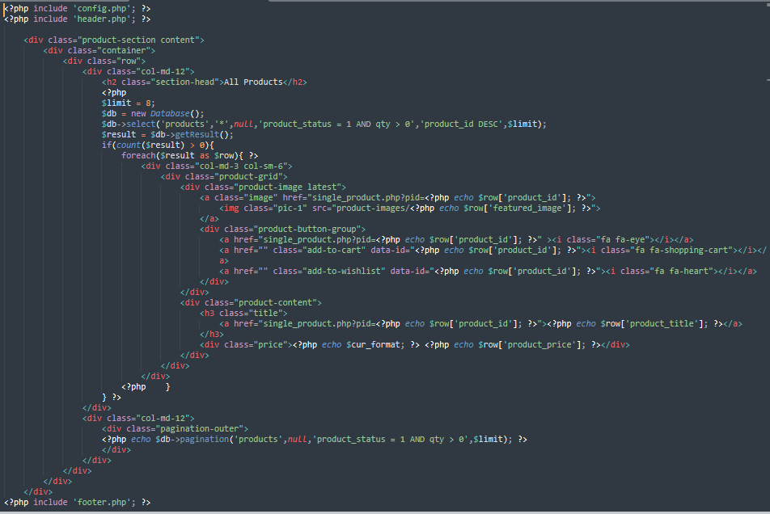

Figure 5: Basic PHP of the Project

**5.2.2 Basic CSS of the Project**

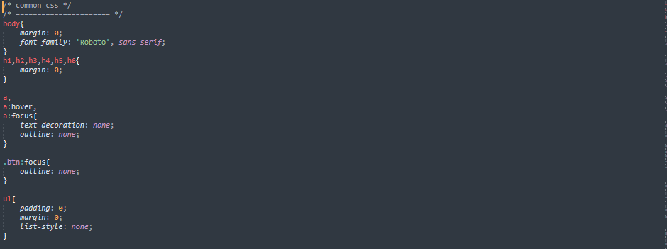

Figure 6: Basic CSS of the Project

**5.3.3 Available products on the website**

Any user with an internet connection can access the online shop. The user can surf the webpage to

see what is available on the website. To get the product, we create a function called which also has a connection to the database. When function is called a relationship is established in the database to

retrieve products from the database.



Figure 7: Available products on the website

**5.3.4 User Registration**

The User will insert his personal information into the registration form.

After submitting the form, a connection is established with the database which saves the data.

The IP address of the customer is also sent to the database to be kept.

The user is expected to provide the necessary information.

Any missing space or wrong information may lead to the customer not being able to register.

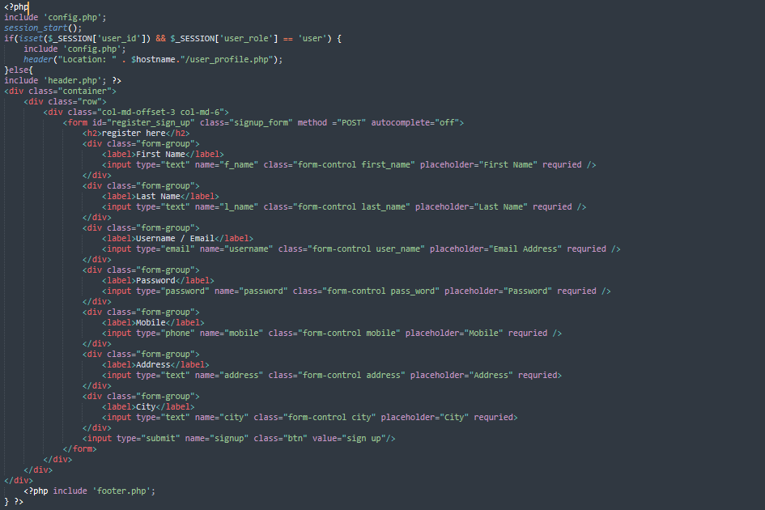

Figure 8: User Registration

# Chapter 6

## Result & Discussion

**6.1 Structure of the project**

* Before Login
  + Login
  + Register
  + Forget Password
  + Administrator Login
  + About Us
  + Contact Us
* After Administrator Login
  + Edit Website Details
  + Add Brands
  + Add Category
  + Add Items
  + Delete Brands
  + Delete Category
  + Delete Items
  + Manage User
    - See Users
    - Users Shopping
    - Add Users
    - Delete Users
    - Logout
* After User Login
  + My Profile
    - Edit Profile
    - Change Password
* Buy Products
  + Categories (Controlled by Admin. Which can be add it dynamically according to their needs)
* My Cart
* My Shopping’s
* Checkout
* Logout

**6.2 Screenshots of the project**

* Home Page

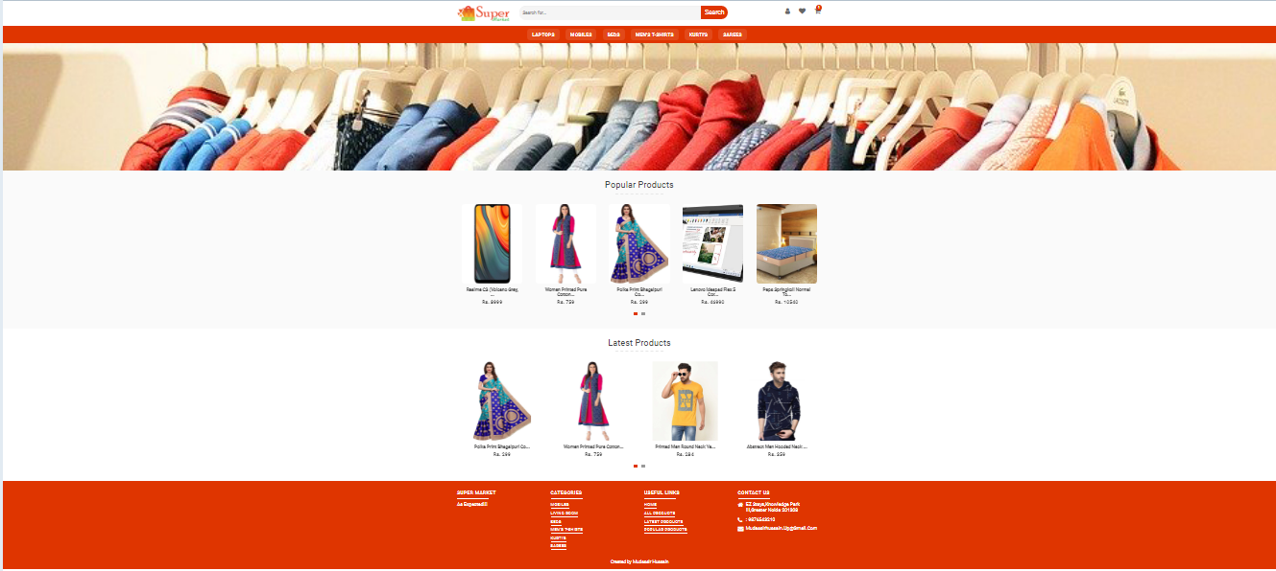

Figure 9: Home Page

* Admin Page

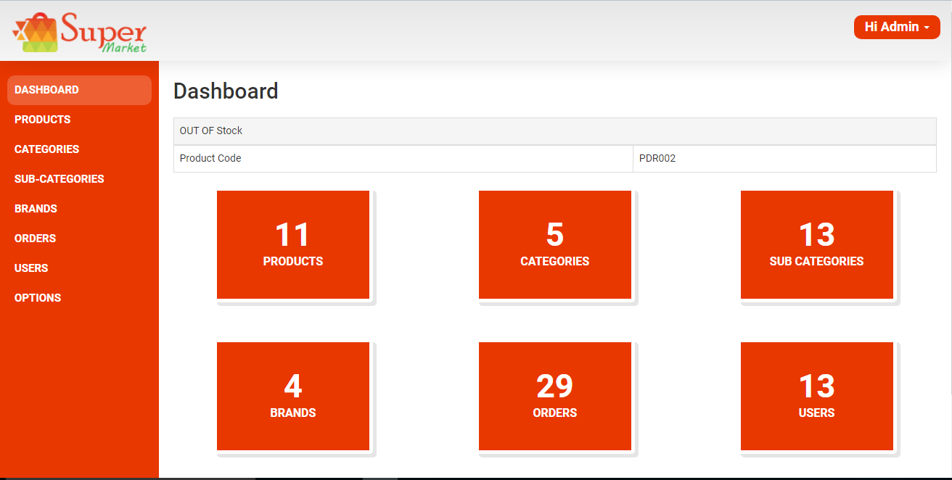

Figure 10: Admin Page

* All Products

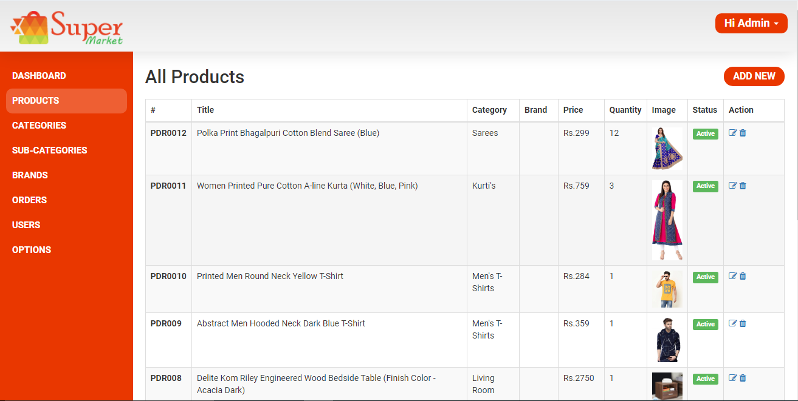

Figure 11: All Products

* Registration Page

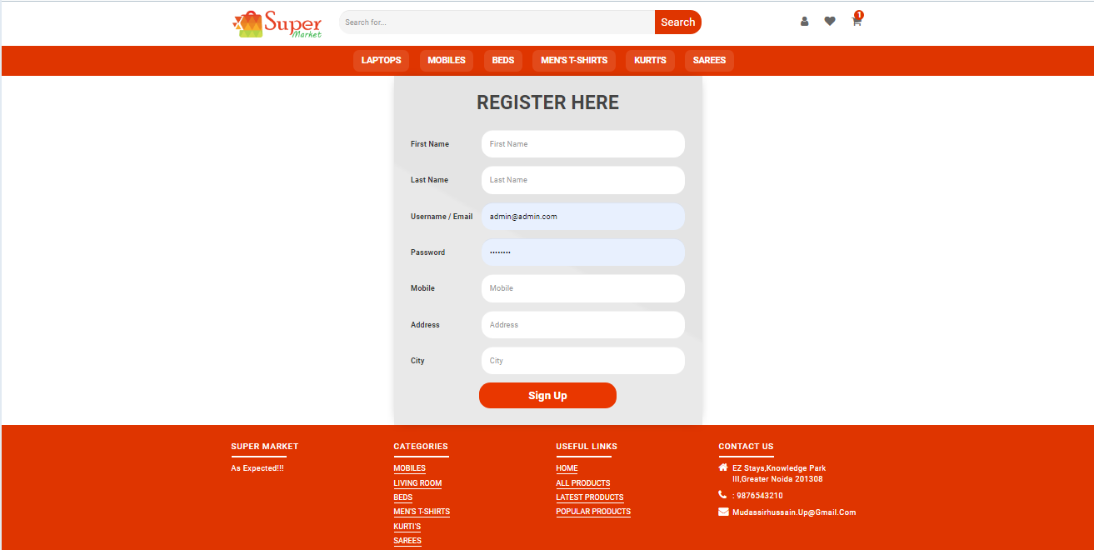

Figure 12: Registration Page

* Login Page

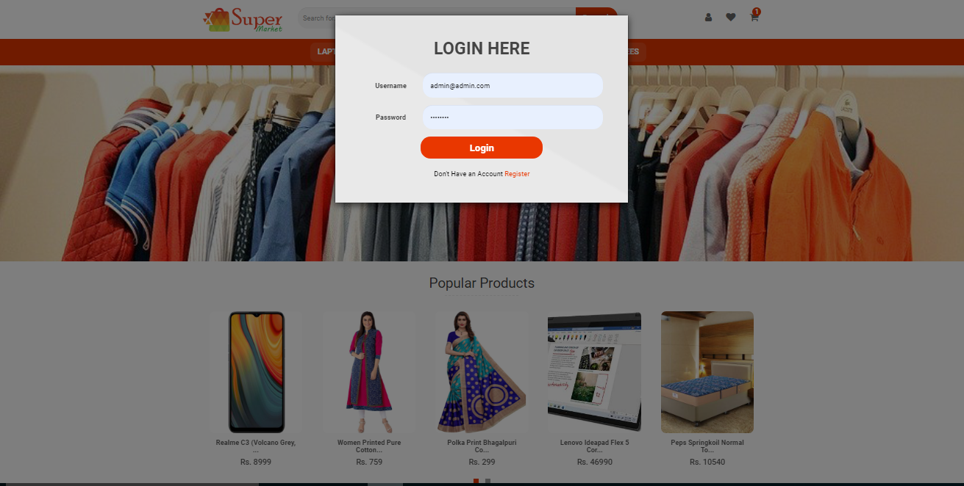

Figure 13: Login Page

* Payment Page

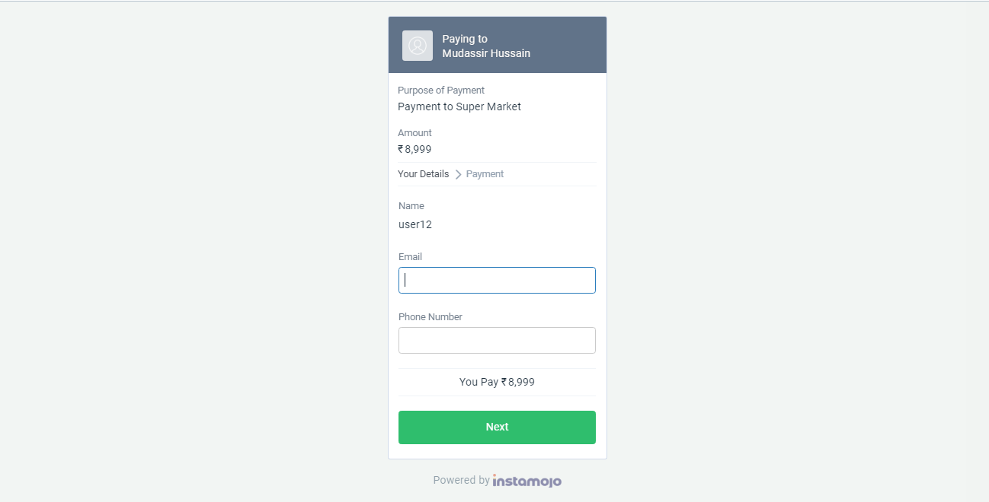

Figure 14: Payment Page

# Chapter 7

## Conclusion, Limitation & Future Scope

**7.1 Conclusion**

To conclude the description about the project : The project, developed using PHP and MySQL is

based on the requirement specification of the user and the analysis of the existing system, with

flexibility for future enhancement. The expanded functionality of today’s software requires an

appropriate approach towards software development.

This ecommerce software is designed Ecommerce site project is developed using PHP, CSS,

Bootstrap, and JavaScript. Talking about the project, it has all the required essential features.

This project has a user side where he/she can view product category and add products to cart and

proceed for checkout whereas from administration side he/she can view sales, number of product,

users, daily sales report, add product and categories. In this project, all the main functions are

performed from the Admin side. User Friendly.

**7.2 Limitations**

Invoices need to be implemented in the website, emails and notifications needs to be sent to customers

for new arrivals or discount. Debit and credit cards needs to be implemented in the shop as well. There have to be language varieties so that none-English users and customers can shop easily without any difficulty.

**7.3 Future Scope**

This activity is also known as the feasibility study. It begins with a request from the user for a

new system. It involves the following:

* Identify the responsible user for a new system.
* Clarify the user request.
* Identify deficiencies in the current system.
* Establish goals and objectives for the new system.
* Determine the feasibility for the new system.

# Chapter 8

## Bibliography and References

**-**Bibliography

* [1]Ayo, Charles K. (2006). “The Prospects of e-Commerce Implementation in Nigeria, Journal of Internet Banking and Commerce”, Vol. 11, No.3, pp. 68-75.
* [2]Laudon, K. and Traver, C. (2008), “ E-Commerce: Business, Technology, Society”, 4th Edition, Prentice Hall, pp.48-67.
* [3]P.T. Joseph, S.J., (2009) “E-Commerce An Indian Perspective”, PHI, pp. 304- 503.
* [4] Vivek S, Rajiv S, (2000) “Developing E-Commerce Sites: An Integrated Approach”, Addison-Wesley, pp. 268

-References

* www.w3school.com
* CSS3 characteristic and attributes
* php features. http://www.biogem.org/downloads/notes/PHP%20- %20Hypertext%20Preprocessor.pdf/4/Javascript academic. Accessed
* http://www.w3schools.com/js/default.asp https://dev.mysql.com/doc/apis-php/en/apis-php-pdo-mysql.html
* Documentation for mysql
* XAMPP https://www.apachefriends.org/index.html
* PhpMyAdmin. https://www.phpmyadmin.internet/
* Sublime Text editor https://en.wikipedia.org/wiki/Sublime_Text
* Instamojo Payment Gateway https://www.instamojo.com